**MOVIE TICKET BOOKING SYSTEM**

**Mini Project 1 A Report**

Submitted in partial fulfillment of the requirement of University of Mumbai

For the Degree of

**(Computer Engineering)**

**By**

1. **Rohini Rai “ID No: TU3F2021141”**
2. **Ruchika Naik “ID No: TU3F2021162”**

**3) Manasi Chavan “ID No: TU3F2021013”**

**Under the Guidance of**

**Prof. Shudhodhan Bokefode**



**Department of Computer Engineering**

**TERNA ENGINEERING COLLEGE**

**Plot no.12, Sector-22, Opp. Nerul Railway station,**

**Phase-11, Nerul (w), Navi Mumbai 400706**

**UNIVERSITY OF MUMBAI**



**TERNA ENGINEERING COLLEGE, NERUL,**

**NAVI MUMBAI**

**Department of Computer Engineering**

Academic Year 2020-21

**CERTIFICATE**

This is to certify that the mini project 1 A entitles “Movie Ticket Booking System” is a bonafide work of

1. **“Rohini Rai” “ID No: TU3F2021141”**
2. **“Ruchika Naik” “ID No: TU3F2021162”**

**3) “Manasi Chavan” “ID No: TU3F2021013”**

submitted to the University of Mumbai in partial fulfillment of the requirement for the award of the Bachelor of Engineering (Computer Engineering).

**Guide Head of Department Principal**

**Project Report Approval**

This Mini Project 1 A Report – entitled “**Movie Ticket Booking System**” by following students is approved for the degree of ***B.E. in "Computer Engineering"***.

**Submitted by:**

1. **“Rohini Rai” “ID No: TU3F2021141”**
2. **“Ruchika Naik” “ID No: TU3F2021162”**

**3) “Manasi Chavan” “ID No: TU3F2021013”**

Examiners Name & Signature:

1.---------------------------------------------------------

2.----------------------------------------------------------

Date: ---------------------------------

Place: ---------------------------------

**Declaration**

We declare that this written submission represents our ideas in our own words and where others' ideas or words have been included, we have adequately cited and referenced the original sources. We also declare that we have adhered to all principles of academic honesty and integrity and have not misrepresented or fabricated or falsified any idea/data/fact/source in our submission. We understand that any violation of the above will be cause for disciplinary action by the Institute and can also evoke penal action from the sources which have thus not been properly cited or from whom proper permission has not been taken when needed.

|  |  |  |
| --- | --- | --- |
| 1. **Rohini Rai** | **“ID No: TU3F2021141”** | --------------------------- |
| 1. **Ruchika Naik** | **“ID No: TU3F2021162”** | --------------------------- |

|  |  |  |
| --- | --- | --- |
| 1. **Manasi Chavan** | **“ID No: TU3F2021013”** | --------------------------- |

Date: _____________________

Place: _____________________

**Acknowledgement**

We would like to express our sincere gratitude towards our guide **Prof. Shudhodhan Bokefode**, Mini Project Coordinators  **Prof. Dr. Sandeep Raskar** for their help, guidance and encouragement, they provided during the project development. This work would have not been possible without their valuable time, patience and motivation. We thank them for making our stint thoroughly pleasant and enriching. It was great learning and an honor being their student.

We are deeply thankful to **Dr. Archana Mire (H.O.D Computer Department)** and entire team in the Computer Department. They supported us with scientific guidance, advice and encouragement, they were always helpful and enthusiastic and this inspired us in our work.

We take the privilege to express our sincere thanks to **Dr. L. K. Ragha**our Principal for providing the encouragement and much support throughout our work.

|  |  |  |
| --- | --- | --- |
| 1. **Rohini Rai** | **“ID No: TU3F2021141”** | --------------------------- |
| 1. **Ruchika Naik** | **“ID No: TU3F2021162”** | --------------------------- |

|  |  |  |
| --- | --- | --- |
| 1. **Manasi Chavan** | **“ID No: TU3F2021013”** | --------------------------- |

Date: _____________________

Place: _____________________

**Index**

|  |  |  |  |
| --- | --- | --- | --- |
| **TABLE OF CONTENTS** | | | |
| **Sr. No.** | **Title** |  |  |
|  | **Abstract** |  |  |
|  | **List of Figures** |  |  |
|  | **List of Tables** |  |  |
|  |  |  |  |
| Chapter 1 | Introduction   * 1. Motivation   1.1.1 Need of the problem  1.2 Scope of the project |  |  |
|  |  |  |  |
| Chapter 2 | Problem Statement   * 1. Problem statement   2. Features   3. Objectives   4. Specifications of the system |  |  |
|  |  |  |  |
| Chapter 3 | Literature Survey |  |  |
|  |  |  |  |
| Chapter 4 | Design and Implementation |  |  |
|  |  |  |  |
| Chapter 5 | Results |  |  |
|  |  |  |  |
| Chapter 6 | Conclusion and future work |  |  |
|  |  |  |  |
|  | Reference |  |  |
|  |  | |  |

## Abstract

Our Mini Project is a Movie ticket booking system . Basically it is a Graphical User Interface (GUI) or a windows based application. This GUI is created by using JAVA language and using certain java concepts like Swing , AWT , Events , IO concepts .We decided to create this application , because now-a-days there is a lot of requirement for this kind of applications . Through this system movie tickets can be booked according to a preferred block , age group , time slot . The seats which are already booked cannot be rebooked again . If we are trying to book the same seat again then a pop up message will appear which will display that the ticket is already booked . After successfully booking the ticket it will also generate the ticket receipt , on which the details like , the block , seat no , timing , age group , and the amount paid for the ticket , everything will be visible on that receipt, so that the print of that receipt can be taken and given to the concerned person . That receipt will be in .txt format . This system also contains one admin login page , through which the admin can login and then he/she can book the tickets of the concerned person . This login page is connected to the main interface, though which the tickets are going to be booked . This login page is created in order to avoid the malpractices or for the security reasons . At the end we have also converted this .jar file to .exe file by using certain softwares , so that this application can be shared with others and they can install it in their device .

**Chapter 1**

**Introduction**

* 1. Motivation:

1.1.1 Need of the problem

1.2 Scope of the project:

* 1. **Motivation:**

There are a lot of movie ticket booking systems which is drastically reducing the human manual work and converting manual work to something which is done automatically, by machine or some automated system. At movie theaters, they are using this type of GUI for booking movie tickets according to customers choice , which in turn is reducing the manual work by handling each and everything automatically from booking ticket to the generation of receipt . This type of GUI also reduces the time and load of the person who is booking ticket. So taking all this points in consideration , we decided to make an application which is somehow similar to this. Which will book ticket according to customer’s choice and generate receipt accordingly.

* + 1. **Need of the problem :**

The need of this kind of application is to reduce the manual work by using machine and some automated system. Utilzing this movie ticket booking system project , proprietor doesn’t need to sit and deal with the whole exercise on paper . This system keeps track of the available seats .

* 1. **Scope of the project:**

It is not an online movie ticket booking system so the user can’t book the ticket online , but it is a desktop based application , we will give this application to any concerned authority who want this kind of application. So that the proprietor will use this application on his/her device in order to do their work efficiently. This application will reduce the manual work , which is the plus point of this application.

**Chapter 2**

**Problem Statement**

* 1. **Problem statement**
  2. **Features**
  3. **Objectives**
  4. **Specifications of the system**
  5. **Problem Statement:**

Project Report of Movie Ticket Booking System Identification of need: The old manual system was suffering from a series of drawbacks. Since whole of the system was to be maintained with hands the process of keeping, maintaining and retrieving the information was very tedious and lengthy. The records were never used to be in a systematic order. there used to be lots of difficulties in associating any particular transaction with a particular context. If any information was to be found it was required to go through the different registers, documents there would never exist anything like report generation. There would always be unnecessary consumption of time while entering records and retrieving records. One more problem was that it was very difficult to find errors while entering the records. Once the records were entered it was very difficult to update these records. The reason behind it is that there is lot of information to be maintained and have to be kept in mind while running the business .For this reason we have provided features Present system is partially automated (computerized), actually existing system is quite laborious as one has to enter same information at three different places.

* 1. **Features :**
* It Provides security to the application because of the login page . So that the administrator will only get the access of booking ticket , as only administrator will have the login id and password.
* Provides the searching facilities based on various factors like seats block, ticket type , time slot .
* The transactions are executed in offline mode , hence online data for seats , booking capture and modification is not possible.
* Manage the information of booking, by showing the information of available seats .
* After booking the ticket , receipt gets generated in “ .txt” format .
* We have used events Action Listener concept , so that each and everything should have correct functionality and the pop up message will appear to guide whether the input credentials are correct or not.
* It reduces the manual work of ticket booking.
* “.jar” to “.exe” conversion for installation of this application.
  1. **Objectives :**

The main objective of movie ticket booking system is to manage the details of Seats, Booking, Customer, Payment, Shows. It manages all the information about Seats, movie, shows. The project is totally build at administrative end and thus only the administrator is guaranteed the access. The purpose of the project is to build an application program to reduce the manual work of managing the Seats, Booking, creating receipts. It tracks all the details about the availability of seats, the amount which customer has to pay, the available time slot etc , and accordingly the receipt gets generated .

* 1. **Specifications of the system:**

For this project the language which we have used is JAVA.

For this application development the IDE used is Eclipse.

And certain concepts like java swing and awt which provides the look and feel to a GUI.

* Swing components :- 1. JFrame

2. JTextField

3. JLabel

4. JButton

5. ImageIcon

6. JOptionPane

* AWT components :- 1. Choice

2. Color

3. Graphics

4. event

* io components :- FileWriter - This concept is used for generating ticket receipt in “ .txt ” format .
* We also made an exe installer of this java application. We converted “ .jar ” file to “.exe ” so that we can share this application with others and they can install it on their device.
* For converting “.jar” into “.exe” and making it available for installation we used two softwares ,
  + 1. Launch4j 🡪 To create an .exe file.
  + 2. Inno Setup Compiler 🡪 builds our application folder and generates “.exe” setup , so that anyone can install it.

**Chapter 3**

**Literature Survey**

We did research of various available movie booking web sites and application. While surveying we mainly focused on the systems of countries like USA, England, Dubai, Singapore and India. While searching and researching we focused basically on the platform in which the application has been developed. Also the various features related to other systems were analyzed to get an idea of what are the features which has already been implemented and what are the features that can be added to the system.

From the past 18 years in South Africa a seed of an idea of book my show was planted. The site was started in 1999, and since then it is one of the most famous online movie booking system. The web site mostly gained its popularity between the years 2006-2010. Book My Show was awarded 'The Hottest Company of the Year-2011-12 and “'The Company to watch out for' at the prestigious CNBC Young Turks Award.In May 2016 BookMyShow awarded ‘Best Omni-channel Customer Experience Brand’ at the One Direct Quest Customer Experience (QuestCX) Awards.It uses a PHP based web site. The web site provides detailed information regarding movies. There are columns in which reviews can be added and published on the web page. These sorts of features are almost common in all the web sites available. User login and sign up are the other features with the help of which user can have authorized access to the web site. Seat confirmation and payment can easily be done using online payment portal which is further connected to banking system. There is also division in the web site for different cities so that it becomes quite easy to search theatre in a particular area. With the increasing online system one more thing has also become popular that is offers and discounts. The web site also provides various offers applied through coupon code. To increase the traffic of application mobile coupon codes has been added much more. Trailer videos, games, offers and events are the other additional modules of the web site to increase the functionality. The site has 34 million apps downloaded till date, 10 million ticket sold per month, and 3billion page view per month.

But the main problem with this existing system is it has been observed that there are lots of bugs in the online movie system. The major issue is speed, and it is almost with all the systems. Due to increasing traffic and demand of online system the system is sometimes not able to bear the load.

For this reason we made an application through which tickets can be booked at the same time when customers want , which saves time of the customers . For this purpose we used the JAVA language . As JAVA is a compiled language , it takes less time to execute a code.

Modern day theatre managers still make use of the same types of reports that were sought decades ago, but have come to expect them instantly, and without error, due to widespread computer usage. A computerised reservation system has the potential to provide the precise type of information required with just a mouse click. Comparing manual and computerised booking systems, Collins (2003, p. 125) quotes a theatre manager describing them as ‘labor intensive, bulky and hard to make changes’ as opposed to ‘fast, easy and sleek’ respectively

**Chapter 4**

**Design and Implementation**

* Conceptual block diagram :-

LAUNCH4j +

INNO SETUP COMPILER

“.jar” 🡪 “.exe”

To generate ticket in “ .txt “

FILE WRITER

MAIN FRAME

TEXT FIELDS

TEXTBOX

BUTTONS

PAINT AND REPAINT

To Repaint once gets selected

Seat Block

* Program Flow :-

Ticket Receipt

* Extra Feature :-

**Chapter 5**

**Results**

1. Admin Login page:-

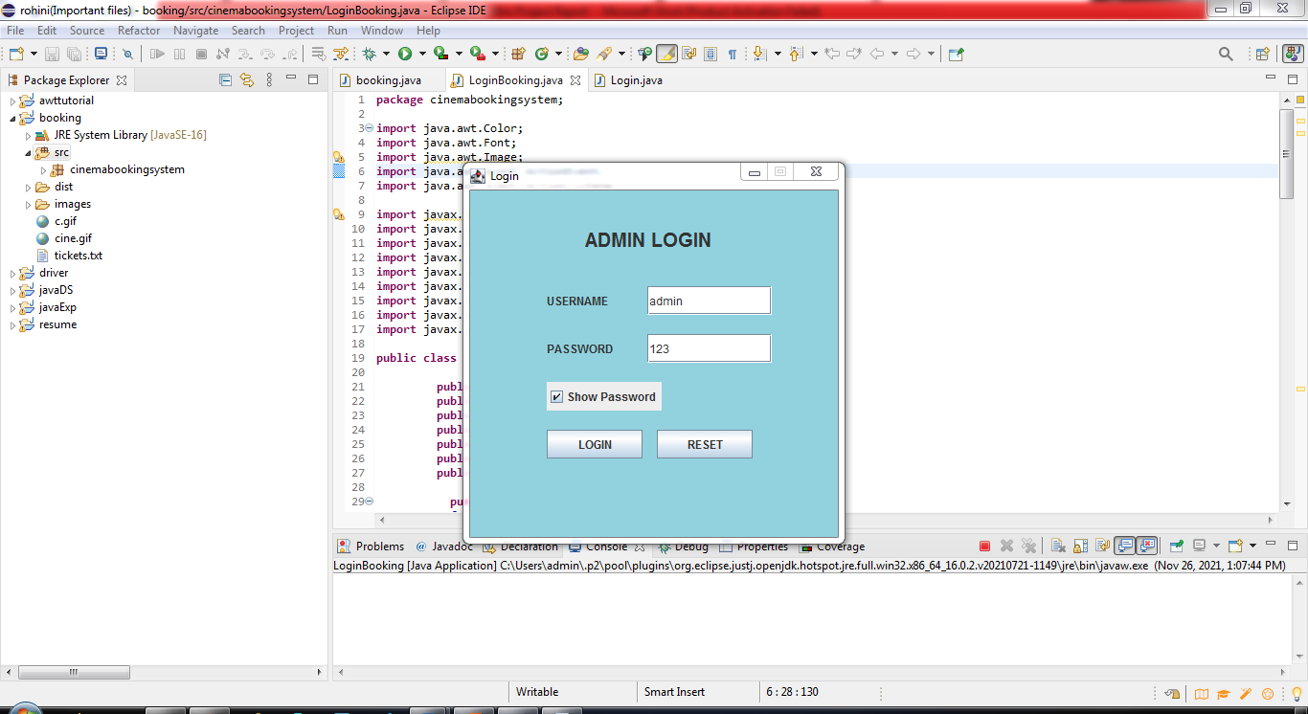

1.1 Successful message:-

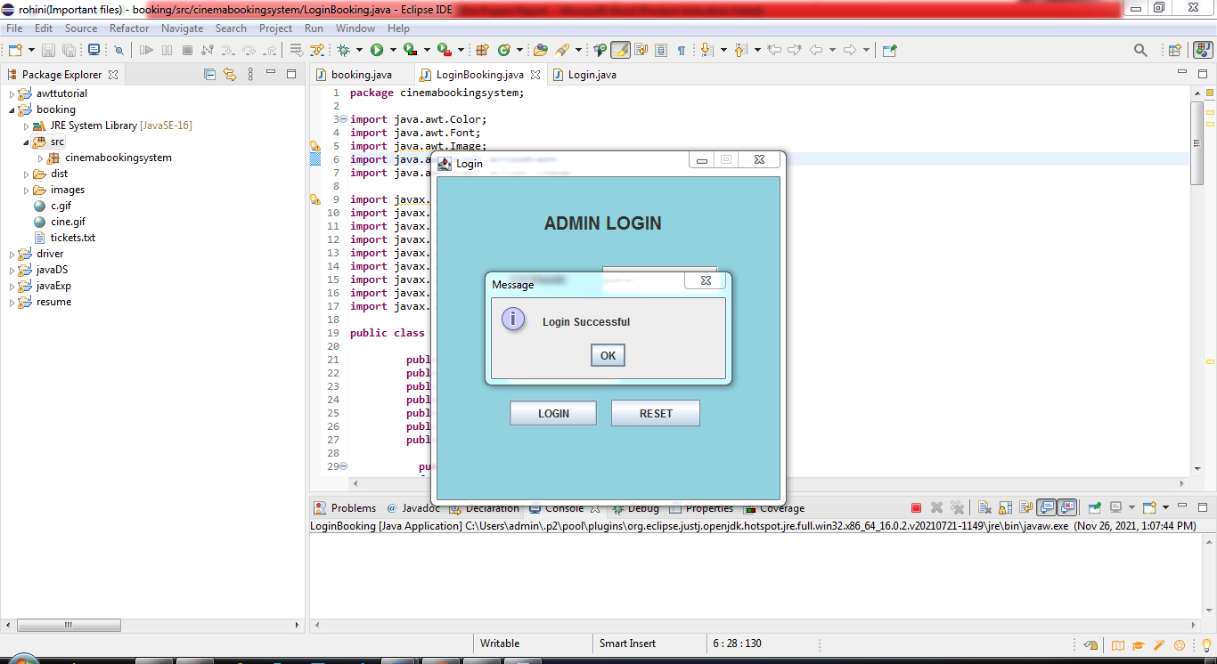

2. Main Interface appears after successful login:-

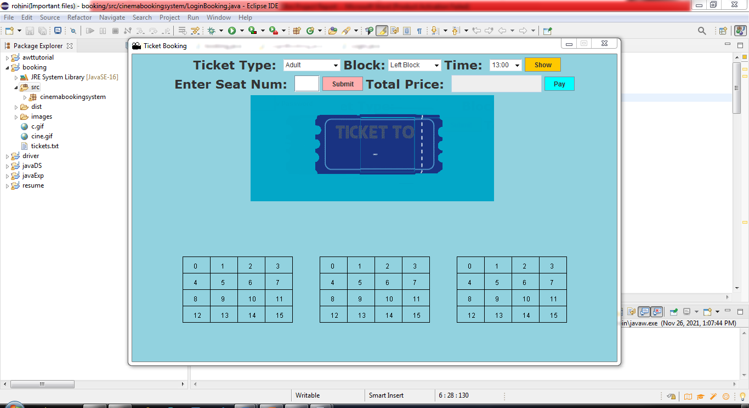

2.1 After entering details in the main interface:-

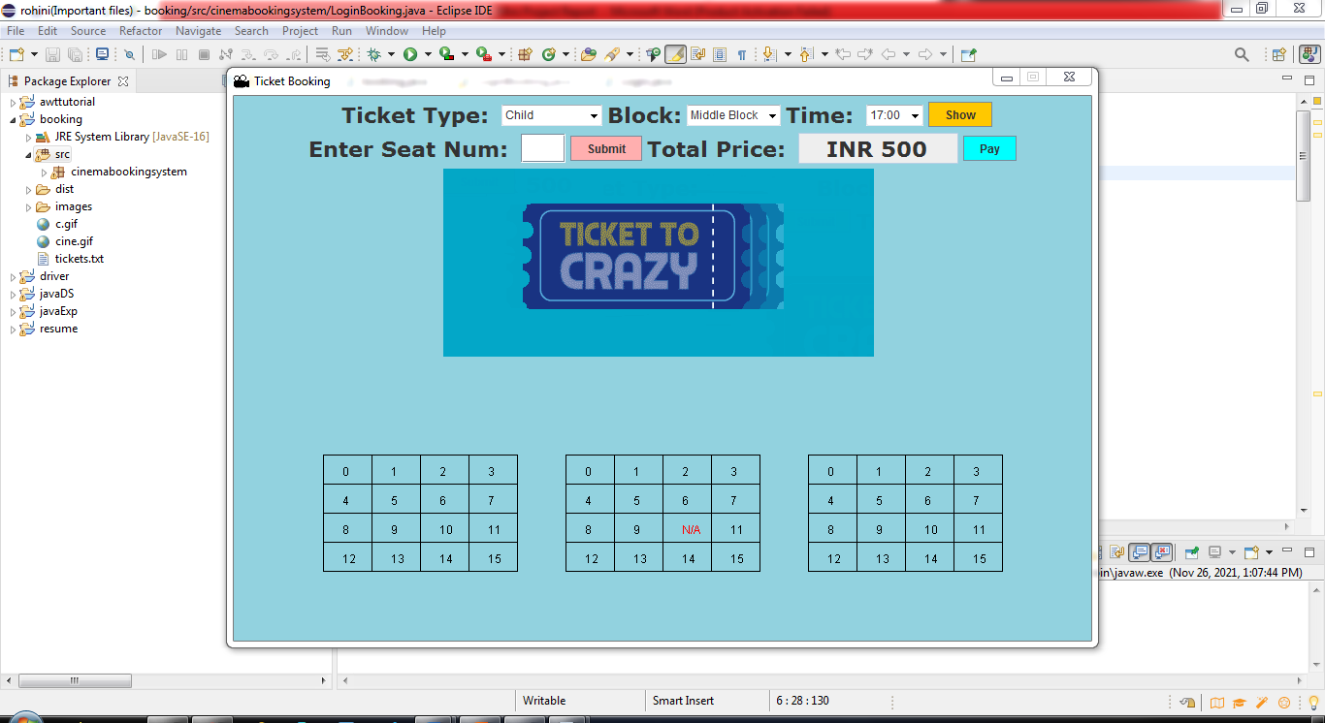

2.2 Success message after clicking on pay button:-

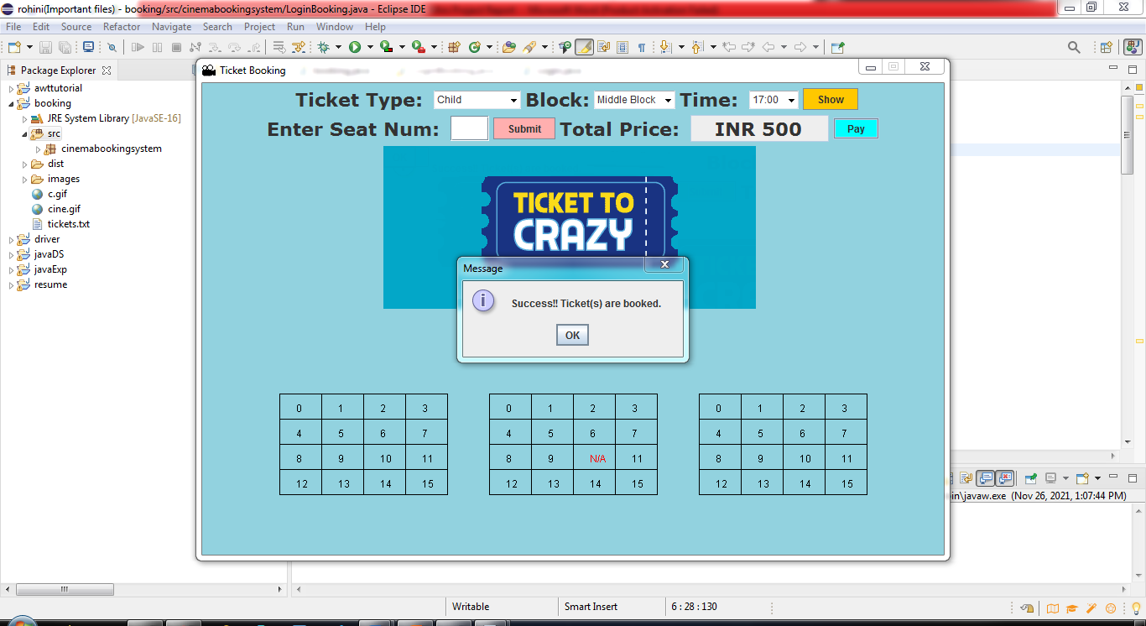

3. Generated receipt after successfully booking tickets:-

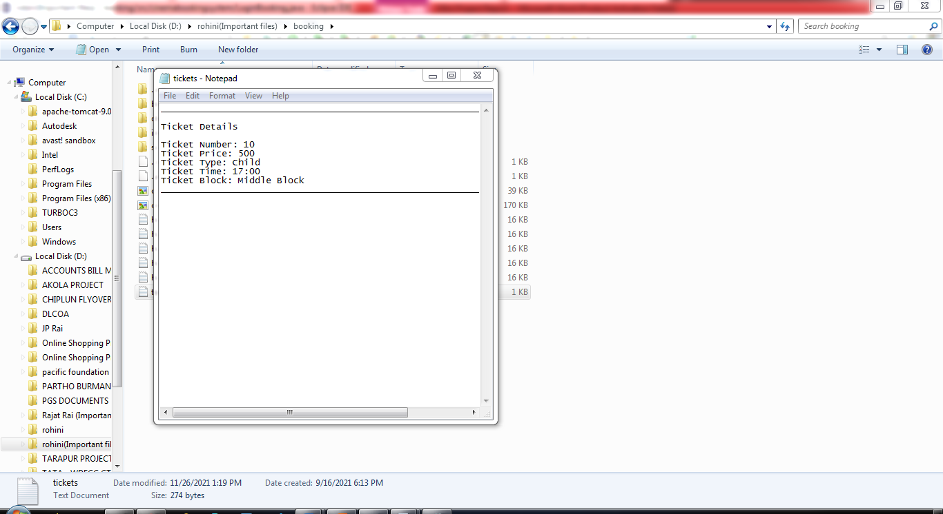

4. .exe setup

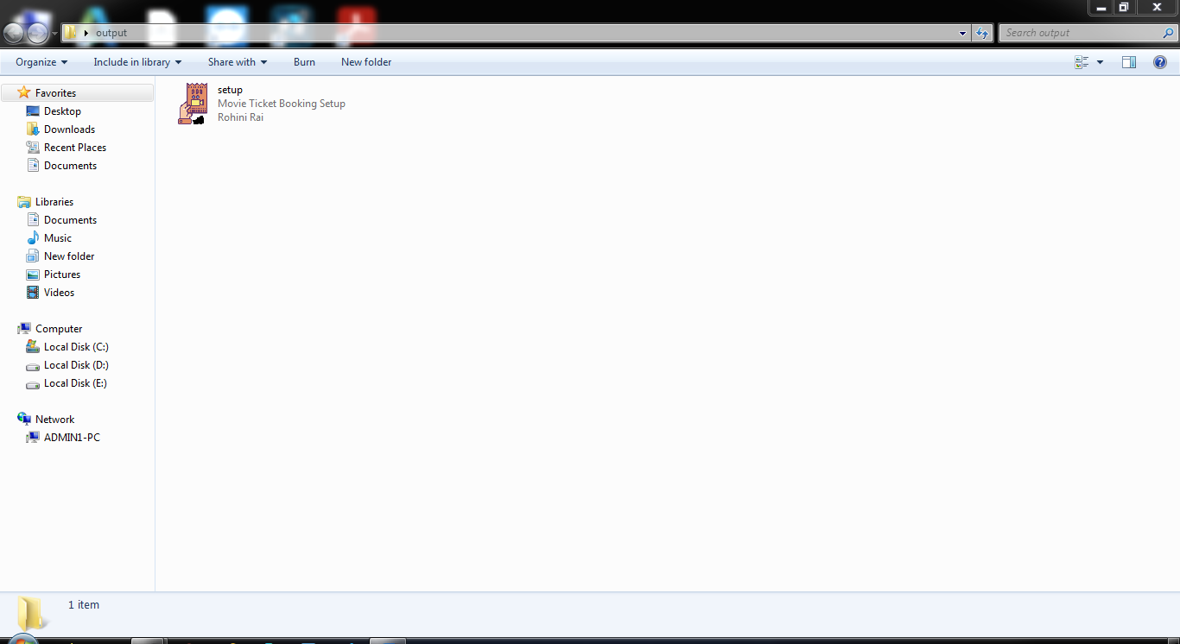

5. After installation it appears on desktop

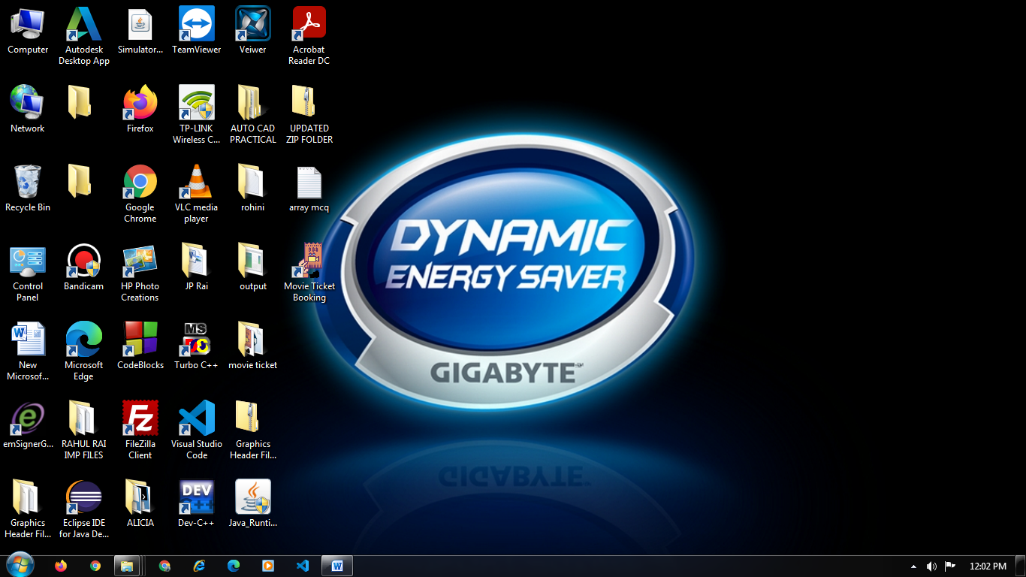

6. Sample codes :

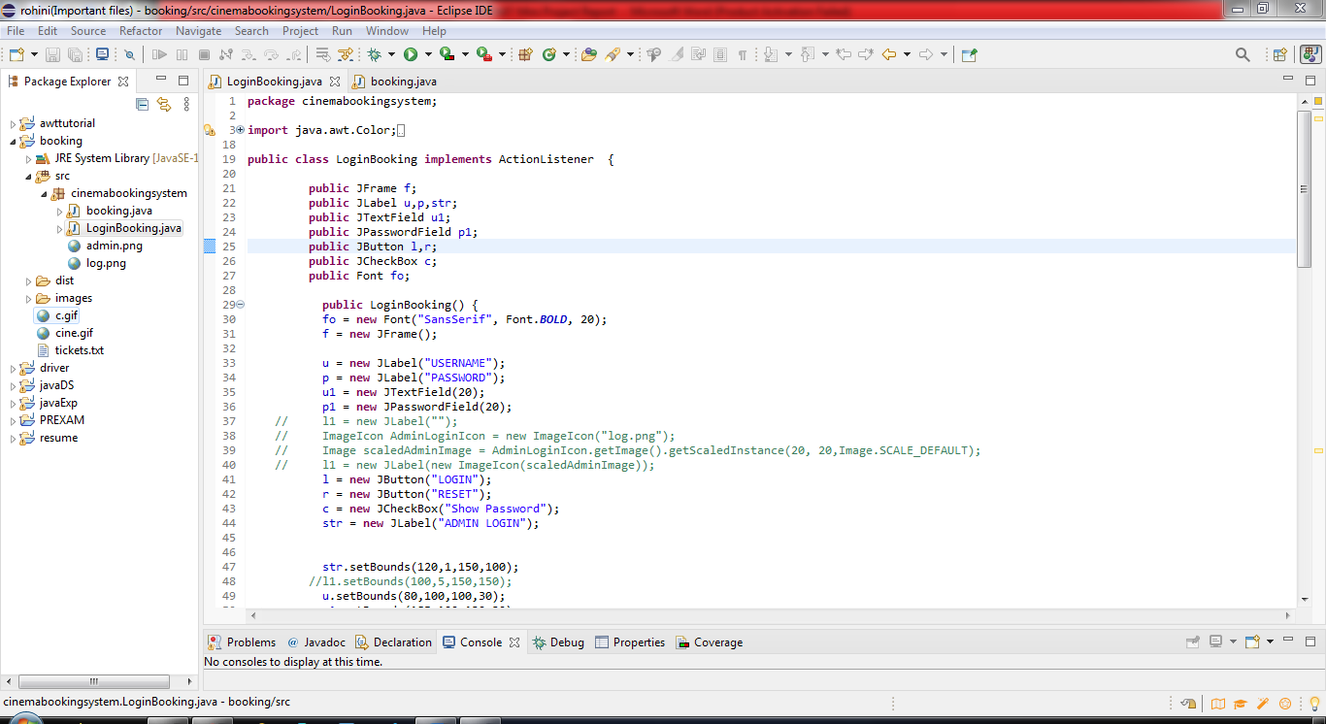

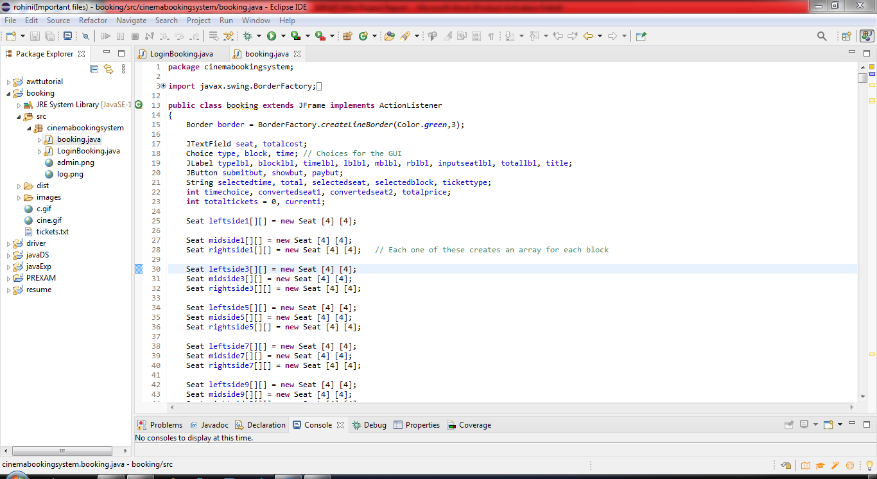

**Chapter 6**

**Conclusion and Future Scope**

**5.1** **Conclusion**

**5.2 Future Scope**

**5.1 Conclusion:**

Finally , in our movie ticket booking system , we have developed a secure, user-friendly movie ticket System. This System can take care of each member whether its Owner or viewer. This System will help them to properly manage the ticket booking system and aid in growth without creating any hassle.

This system is completely secure since the owner is provided with a user ID and Password, so there is no chance of any unauthorized access .The owner can book the ticket and give the generated receipt to the customer . So, using this system will help in reducing the manual work and provides efficiency in booking tickets . So, the system is beneficial for the viewers as well as owners.

**5.2 Future Scope :**

In future this project can be converted in an online mode with advance features. This project also has the scope of enhancements like:

1. Direct delivery of Online Booking of Purchases of eatables (coldrinks, popcorn etc) can be provided .
2. Corporate/bulk booking:for corporate presentation /meetings the and bulk booking etc. Conference facility can be provided for corporate meetings in the hall. Any institute/company can book the tickets for students/clients and special discount will be provided to them.

**References**

* “JAVA The Complete Reference”, by Herbert Schildt
* “ Programming with Java”, by E Balagurusamy.
* [Websites :-](https://www.googleadservices.com/pagead/aclk?sa=L&ai=DChcSEwjYkKiTmuzzAhVWDisKHctUArwYABAAGgJzZg&ae=2&ohost=www.google.com&cid=CAESQeD2PiU8Vn_VuaiqPdRP4YswSPvWmjNHj7nXdIPIHZcDepLzoa91cVtwoMvZJZdp03BB0ME1NTffzf0gZlC7q0-_&sig=AOD64_0kEWBb356kn4IVui9soZd4Inf38w&q&adurl&ved=2ahUKEwihvJaTmuzzAhVB8HMBHbDTDgUQ0Qx6BAgCEAE)

1. GeeksForGeeks

<https://www.geeksforgeeks.org › java>

1. [Javatpoint](https://www.googleadservices.com/pagead/aclk?sa=L&ai=DChcSEwjYkKiTmuzzAhVWDisKHctUArwYABAAGgJzZg&ae=2&ohost=www.google.com&cid=CAESQeD2PiU8Vn_VuaiqPdRP4YswSPvWmjNHj7nXdIPIHZcDepLzoa91cVtwoMvZJZdp03BB0ME1NTffzf0gZlC7q0-_&sig=AOD64_0kEWBb356kn4IVui9soZd4Inf38w&q&adurl&ved=2ahUKEwihvJaTmuzzAhVB8HMBHbDTDgUQ0Qx6BAgCEAE)

[https://www.javatpoint.com › java-tutorial](            https://www.javatpoint.com › java-tutorial)

1. Oracle

[https://www.oracle.com › java](https://www.oracle.com/in/java/)

1. W3SCHOOLS

<https://www.w3schools.com › java>

1. Tutorialspoint

<https://www.tutorialspoint.com › java>